
As the Rotor Turns: Wind Power & You (Lesson Plan)

(An Investigation of Wind Power as an Energy Resource in Pennsylvania)
Suggested Grade Level 6-8

Overview
Engineers of the future, step forth! Students will get acquainted with the basics of wind energy and power production by fabricating and testing various blade designs for table-top windmills constructed from one-inch PVC pipe and balsa wood (or recycled materials). The suggested time frame for this lesson is three to four (3-4) 50-minute class periods.

Standard Statements:
3.2.7 B Apply process knowledge to make and interpret observations.
3.2.7 D Know and use the technological design process to solve problems.
3.4.7 B Relate energy sources and transfers to heat and temperature.
3.5.7 B Recognize earth resources and how they affect everyday life.
3.6.7 C Explain physical technologies of structural design, analysis and engineering,
personnel relations, financial affairs, structural production, marketing,
research and design.
3.8.7 C Identify the pros and cons of applying technological and scientific solutions to
address problems and the effect upon society.
4.2.7 A Know that raw materials come from natural resources.
4.2.7 B Examine the renewability of resources.

Content Objectives
Students will know that
- Wind is an important form of energy because it is clean, safe and perpetually renewable.
- Modern technology has improved blade design based on already successful technology of aircraft propellers and aircraft wings to increase the efficiency of wind turbines.
- There are geographic, social and economic constraints affecting the placement and viability of wind farms.

Process Objectives
Students will be able to
- Describe how wind is generated by the uneven solar heating of the earth.
- Analyze the transformations of energy involved in electricity generation by wind machines.
- Demonstrate how electricity is generated using a wind power generation device of their own construction and evaluation.
- Discuss how the design of wind turbine components is related to the power it generates.

Assessment Strategies
- Evidence of student understanding based on completion of written handout materials.
- Participation in classroom and small group discussions.
- Evaluation of student design and construction of table-top wind turbines.

Materials
Part 1:
- Teacher computer with internet connectivity
- Projection equipment
- Websites:
  - Wind Generation
http://www.windpower.org/en/tour/wres/coriolis.htm
http://www.pserie.psu.edu/academic/science/degrees/biology/energyfieldtrips/windIndex.htm
  - Beaufort Scale
http://www.mountwashington.org/discovery/arcade/wind/beaufort.html
- Student Handouts
- Clipboards or writing surfaces for student groups
Parts 2 & 3:
- Pennsylvania map (paper or electronic: if electronic, you will need a teacher computer and projection equipment)
Per Group:
- Kidwind Basic PVC Wind Turbine Kit or comparable resources to build a table top wind machine (detailed list included on page 4 of the student handout)
- Multimeter
- Desktop-sized fan
- Blade materials (variable-student determined)
- Student Handouts

Multimedia Resources
Video Sequences:
- Sequence 1: Wind Turbine Specifications & Construction
  - Foundation [0:45]
  - Building the Road [0:30]
  - Bringing in Parts [0:43]
  - Specs and Process [1:10]
  - Blade onto Tower [0:54]
  - Environmental Concerns [1:23]

- Sequence 2: Capacity Factor
    - Topography [0:48]
  - Turbine Production [1:01]
  - Turbine Type and Specs [0:33]
  - Power Grid [0:49]

Additional Resources

Below are some websites that provide useful information related to this lesson's topic.

- The American Wind Energy Association
http://www.awea.org/
This Web site has a well-written section of FAQ's as well as references to more technical applications of wind energy.
- Investigating Wind Energy
http://sln.fi.edu/tfi/units/energy/windguide.html
This site is an elementary level unit from the Franklin Institute in Philadelphia on investigating wind energy. It includes many cross-curricular activities as well.
- The National Renewable Energy Laboratory
http://www.nrel.gov/
This site for the U.S. Department of Energy's lab for renewable energy research and development includes many links to other sites and activities. This lesson's directions for building wind turbines were adapted from this site.
- Re-Energy
http://www.re-energy.ca
This site is provided by the Pembina Institute in Canada, which describes itself as a non-profit think tank and activist organization. It features backgrounders on renewable energy and technology, as well as detailed construction plans for renewable energy models, including a complex wind turbine model suitable for high school science projects.
- Wind Power
http://www.pbs.org/newshour/bb/environment/jan-june01/blowing.html
This April 5, 2001 segment from THE NEWSHOUR WITH JIM LEHRER discusses business and legislative aspects of the wind power industry.
- WindPower.org
http://www.windpower.org/composite-8.htm
The Danish Wind Energy Association has produced an excellent site listing information, activities, and a FAQ. It has a special section entitled, "Wind with Miller" that focuses on explanations and activities for students.

Renewable Energy Glossary:
- http://www.horizonwind.com/forteacherskidsconsumers.asp?id=8

Procedures

Part 1: Filling Our Sails: Where Does Wind Come From? (1, 50 min Class Period, Hmwk)
- Before students begin construction of their table-top wind turbines, allow them to go outdoors and make and record some observations in pairs about the current on page 1 of the student handout.
- Return students to the classroom to elicit their ideas about how wind is generated.
- After hearing a few student responses to the question, “How is wind created?” discuss the formation of wind currents with students using a simulation from The Danish Wind Energy site under the “Wind” tab: http://www.windpower.org/en/tour/wres/coriolis.htm or at Penn State Erie’s “Renewable Energy Field Trips”: http://www.pserie.psu.edu/academic/science/degrees/biology/energyfieldtrips/windIndex.htm.
- Allow students to work in small groups to recapitulate their explanation of what is happening in the simulation of wind currents forming and prompt them to make additional notes from their group discussion on page 1 of the student handout or in any lab journals used in your classroom.
- Reconvene to wrap-up the class period by sharing and clarifying observations.
- Assign reading of “Power in the Wind…A Simple Look” [page 2 in the student handout] for homework.

Part 2: The Power Equation and Wind as an Energy Resource (30 minutes)
- Review the power equation included in the reading and explain that engineers designing and developing wind turbines face the same challenges that they will in upcoming class periods as they construct a table-top wind turbine.
- Show students a Pennsylvania map and allow them to assist you in finding the Bear Creek site near Wilkes-Barre, PA.
- Share the first video sequence (Wind Turbine Specifications and Construction) of the Bear Creek Wind Farm tour with the class (approx. 6 minutes, in 6 segments).
- Gather students’ thoughts on the video and make a list or concept map of student ideas about wind as a renewable resource for producing electricity on the board. Concerns to include may be environmental, political, and economic.
- If time allows, break students into groups for wind turbine construction that begins in Part 3.

Part 3: The Construction & Evaluation of a Wind Turbine (2-3, 50 min Class Periods)
- Put students up to the task of building their own table-top wind turbine by working through Part 3 of the student handout (begins on page 3). This section is materials-intensive and it may be useful to invite students to gather and bring in materials in advance if you are not ordering wind turbine building kits for the lesson.
- Before students move on to Steps 4-6 of Part 3, share Bear Creek video sequence 2 (Capacity Factor) to think about wind turbine design and the factors that affect power production (approximately 4 minutes, 4 segments).
- Set students free to work through Steps 4 and 5 to get blades on their wind turbines and do some initial testing.
- Once all student groups have had an opportunity to make certain that their blades are secure and that their turbine is worthy of producing power, demonstrate the procedure for measuring the power output of a turbine for the class.
- Allow teams to proceed through Step 6 of the student handout to calculate the amount of power their individual turbines are producing.
- Share out teams’ results and discuss students’ beliefs about how the power output for the wind turbines could be improved.
- Allow student teams to decide whether they would like to explore wind speed or blade design and assist them in designing experiments (Step 7) to collect data about their claims. (If you would prefer to have students work through a more structured experiment with their turbines, please see www.kidwind.org’s curricular materials section for lessons entitled, “Wind Power Curves” and “Wind Blade Design.”)

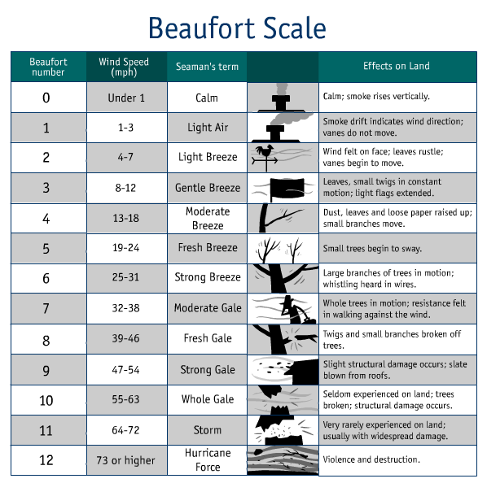
Source: http://www.mountwashington.org/discovery/arcade/wind/beaufort.html

As the Rotor Turns: Wind Power & Your Worldview (Teacher Notes)

(An Investigation of Wind Power as a Sustainable Resource in Pennsylvania)
Notes on Part 1
Beaufort scale history: The Beaufort scale was one of the first scales to estimate wind speeds and the effect of wind on land and sea features was created by Britain's Admiral Sir Francis Beaufort (1774-1857). He developed the scale in 1805 to help sailors estimate the winds by making visual observations. The scale starts with 0 and goes to a force of 12. The Beaufort scale is still used today to estimate wind strengths and without using any complicated equipment!

Notes on Parts 2 and 3
One of the most challenging pieces of these sections to present and help your students to wrap their minds around is the idea of power. Please view the, “Power in the Wind” PowerPoint presentation from Walt Musial of the National Wind Technology Center to pull together resources that will best suit your students’ level of experience with this concept. A good statement to make for kids is that a wind turbine works the opposite of a fan. Instead of using electricity to make wind, like a fan, wind turbines use wind to make electricity. The wind turns the blades, which spin a shaft, which connects to a generator and makes electricity.
In the following diagram that is presented on page 10 of the student handout, the transformation that should be clear is that kinetic energy is being transformed into electrical. Depending upon the level of depth to which the information is presented, you may find it useful to spend some time discussing the difference between an inverter (which turns direct current, or DC, from the turbine to alternating current, or AC, to a transmittable form) and a transformer. (The transformers shown in the diagram may be misleading and this is an important point to convey to students).
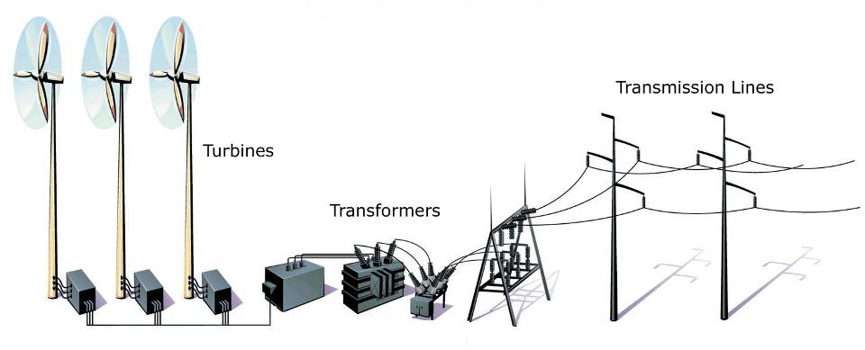

Kinetic (technically derived from solar)
Mechanical
Electrical

The Kidwind website is one of the most comprehensive resources for getting kids excited about wind energy and helping educators to think and work through the details of experimenting with table-top wind turbines in the classroom. At the following website, http://www.kidwind.org/materials/buildingwindmills.html there are many great frameworks to use, as well as a helpful compilation of troubleshooting suggestions for building classroom turbines which is included on the next page.
Wind Turbine Troubleshooting Guide from Kidwind

Why won’t my dowels fit into the Tinkertoy hub?
Sand more! Or you can cut some slits in the end of the dowel. If sanding is a pain then you should head out and buy yourself some Tinkertoys. They work great but are a bit expensive!

Why are the dowels flying out of the hub?
You sanded too much!

Why won’t the rotor spin when I put my turbine in front of the fan?
Check the orientation of the blades. Are your blades oriented in the same direction? Are they flat? Are they hitting the tower? Look at some pictures of old and new windmills to get some ideas about how to orient your blades.

Why does the turbine slow down when I attach it to load (pump, bulb, motor)?
Loading the generator forces it to do work. This makes it harder to push electrons through the circuit. The more load you add the harder it is for the generator to turn and the more torque you must generate from the blades. The only way to do this is to make bigger blades or relocate your wind turbine to a place with higher wind speeds.

Why are the readings on my multimeter all over the place?
Your readings are fluctuating because the wind coming out of your fan is fluctuating. It can also be caused because your blades are not spinning smoothly. This can be caused by blades that are not balanced, evenly distributed or are causing unequal amounts of drag.

What are the best blades?
That is for you to figure out! Lots of testing and playing will get you closer to your answer.

Is a fan a good wind source to test with?
Well, it is the best we have got, unless you want to build or have a wind tunnel handy. The wind that comes out of a fan has a great deal of rotation and turbulence. It isn’t very smooth. While it will still make your turbine spin it is not exactly like the wind outside. To see this turbulence, hold a short piece of thread in front of a fan and move it from the center out. It should head out straight all the time...does it?

Can I take my turbine outside? Can I leave it there?
You can certainly take, use and test your wind turbine outside. But unless you have a yawing turbine it will not track the wind and may not perform optimally. To make it work well you will have to continually face it into the wind. I would not leave your turbine outside for too long. It is designed for basic lab tests and not to endure the rigors of the outdoor environment!

Based on the power in the wind equation it seems that longer blades should make more power. On my turbine this is not true!! WHY??
The blades on your turbine may be bigger than the diameter of the fan. If that is the case, the extra part is only adding drag so your blades will slow down. Additionally if you poorly design large blades they will have lots of drag near the tips and slow down. This will negate any positive effect of the added length. Also short blades spin faster than long ones, so if you are just recording voltage they will seem better. Try short blades with a load in series and see if they have enough torque to spin. Many cases they do not!
Notes on Special Materials from Kidwind

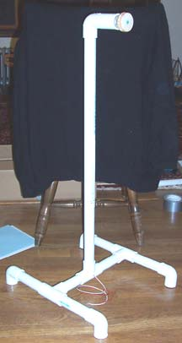
Kidwind sells all of the parts for the Basic PVC Wind Turbine. These are easy to build and for a classroom of 25 kids, at least 3 set-ups are recommended. Listed below is a parts list for the wind turbine shown at the right.
PVC Pipe & Fittings
Head to your local hardware store or Home Depot the prices are not that bad and you don’t need too many parts. All pipe is 1”. This turbine has:
(5) 1” PVC 90° Fittings
(3) 1” PVC T Fittings
(5 ft) 1” PVC Pipe
(1) 1” PVC Coupler

DC Motor, Wires & Clips
A local electronics shop or Radio Shack will have wire, clips and multimeters. Kidwind also sells some of these materials. There are also a variety of online vendors. The DC Motor we use is the Motor 500 by Pitsco. Other motors will work, but we have tested many of them and this is a very smooth spinning and has high output! This turbine has:
(1) Motor 500 (Pitsco)
(4 ft) 22 Gauge Hook Up Wire
(2) Clips (Alligator or Banana)

Special Parts
The Tinkertoy hub, adapters and the Delrin 6 hole hub are specially made for our turbines. But for years we used to fashion your own using Tinkertoys. Head to your local toy shop or an online vendor to get yourself a barrel of Tinkertoys. A small junior barrel will run around $20 and have plenty of materials for your turbines. When you want something rugged and tested though come to Kidwind.
◊ (1) Crimping or Tinkertoy Hub w/ sold by Kidwind
Tools & Materials
To build this turbine you’ll need a drill, pliers, ruler, PVC cutter, hacksaw, wire strippers, soldering iron, solder, duct tape, epoxy and probably lots of other stuff that we can’t recall! Most of all have fun and be safe!

As the Rotor Turns: Wind Power & You (Student Handout)

(An Investigation of Wind Power as an Energy Resource in Pennsylvania)
Part 1: How is wind created?

- Use the scale above to make an observation about the wind conditions outside of your school today. Record your observations in the box below.

Date: Time:

Beaufort number:
Land Effects observed:

- Even if there is not much wind blowing today, think about a time when a gust blew your hat from your head or rustled leaves in a tree above you. How do you think wind is created?

Part 2: Power in the Wind…A Simple Look

If a large truck or a 250 lb. linebacker was moving towards you at a high rate of speed, you would move out of the way right?
Why do you move? You move because in your mind you know that this moving object has a great deal of ENERGY as a result of its mass and its motion. And you do not want to be on the receiving end of that energy.
Just as those large moving objects have energy so does the wind. Wind is the movement of air from one place on earth to another. That’s the motion part.
What is air though? Air is a mixture of gas molecules. It turns out that if you get lots of them (and I mean lots of them) together in a gang and they start moving pretty fast they can definitely give you, a sailboat or a windmill a serious push. Just think about hurricanes, tornadoes or a very windy day!
Why aren't we scared of light winds while we stay inside during a hurricane or wind storm? The velocity of those gangs of gas molecules has a dramatic impact on whether or not we will be able to stay standing on our feet. In fact, in just a 30 mph gust you can feel those gas molecules pushing you around.
Humans have been taking advantage of the energy in the wind for ages. Sailboats, ancient wind mills and their newer cousins the electrical wind turbines have all captured the energy in the wind with varying degrees of effectiveness. What they all do is use a device such as a sail, blade or fabric to "catch" the wind. Sailboats use energy to propel them through the water. Wind mills use this energy to turn a rod or shaft. A simple equation for the Power in the Wind is described below. This is instantaneous and does not take time generating power into consideration.

P = 1/2 ρ∏ r² V³
ρ = Density of the Air
r = Radius of your swept area
V = Wind Velocity

From this formula you can see that the size of your turbine (radius of your turbine squared or r²) and the velocity of the wind (V³) are very strong factors when it comes to power production. If we increase the velocity of the wind or the area of our blades we increase power output. The density of the air has some impact as well. Cold air is more dense than warm air so you can produce more energy in colder climates (as long as the air is not too thin!).
You could calculate the peak power production of your wind turbine using this equation. It will be way off since it leaves out a number of variables that impact the actual power output of your turbine. This includes things like how well your blades transform the energy in the wind and the efficiency and type of generator that you are using. It might be fun to calculate the hypothetical and compare it to how much you are producing and generate some efficiency numbers.Be prepared to be shocked at how low your efficiency is.
Part 3: Build the Basic PVC Wind Turbine
Engineers of the future...Step forth!
Student Handout
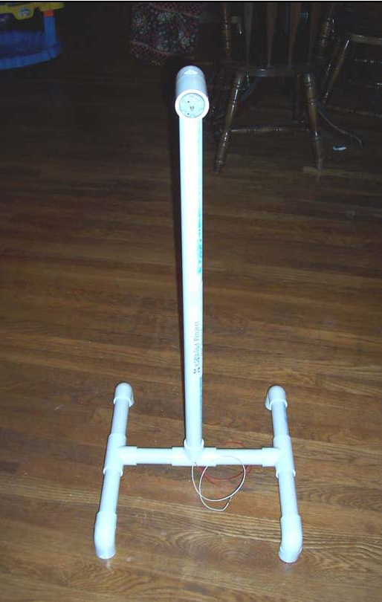


Copyright ©2005

All materials and photographs included in this handout have been made available with written permissions from the Kidwind Project, 2093 Sargent Avenue Saint Paul, MN 55105
http://www.kidwind.org

Kidwind’s production of this document was supported in part by the National Renewable Energy Laboratory through subcontract LEE-5-55877-01.
Step 1: Collect Materials
Materials You Need — PIPE IS 1” PVC Pipe!!
- (1) Some type of Hub
- (1) Some type of DC Motor
- (6) 6” long pieces PVC Pipe
- (1) 2” long pieces PVC Pipe
- (1) 24” long pieces PVC Pipe
- (5) 90° Pipe Fittings
- (3) T Pipe Fittings
- (1) Coupling Fitting

Tools & Materials NEEDED!!
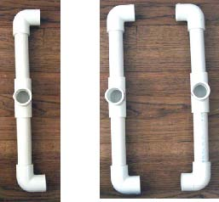
Saw or PVC Cutter, Wire Strippers, Wire, Solder, Duct Tape, Epoxy, Drill, Blade Materials, Hoy Glue, Hobby Knife or Scissors

Building the PVC Tower Base

- Using (4) 90° PVC fittings, (2) PVC tees and (4) 6” PVC pipe sections construct the two sides of the PVC turbine base. Make sure in this step to use the PVC tees that DO NOT have a hole drilled in them.
- Fit the parts together without using glue (PVC glue is really nasty stuff). To make them fit snuggly you can tap them together with a hammer, or bang them on the floor once assembled.
3. Next you need to connect the two sides. Use the PVC Tee with the hole to do this. You need the hole to snake the wires from the DC motor out.

2 Identical Base Sides

Sides joined together. Make sure to use the PVC tee with the hole so you can get the wires out!

PVC Tee with Hole

Step 2: Building the Rotor and Hub
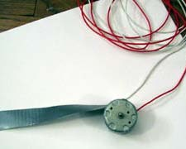
1. For this step you need (1) PVC 90 fitting,
(1) PVC coupler, (1) 3’’ piece of PVC pipe
and a DC motor that is around 1.1” in
diameter.
- Wrap a piece of duct tape around the outside of the motor. This will help the motor fit securely into the PVC coupler. To make it really solid you can epoxy it in.
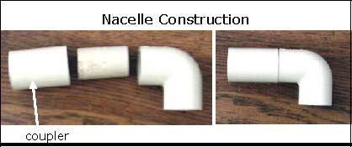
Arrange the pieces like the image to the right. Then push them together to make a solid piece. It is called the nacelle and it holds the DC motor, blades and other equipment.
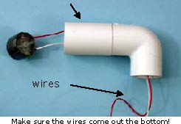
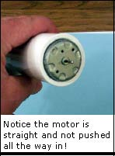
- Insert the wires attached to the DC motor through the nacelle. They should come out of the 90° PVC fitting. Your motor will rest in the coupler.
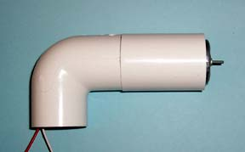
- Insert the motor into the coupler. It should fit very snuggly. If it is loose you should wrap some more duct tape around the outside. As you are frequently pushing on the motor you need to make sure this is tight!
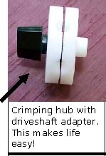
- When you insert the motor you also should make sure that it is straight and not too far in. If it looks cockeyed you should straighten it out as it will cause your hub and blades to wobble while spinning.
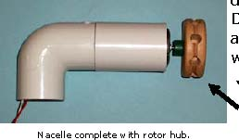
- After you have secured the motor attach your hub. Press the hub onto drive shaft. It should fit very snug. Do not press it on so hard that the adapter rubs on the motor body. This would slow your drive shaft.

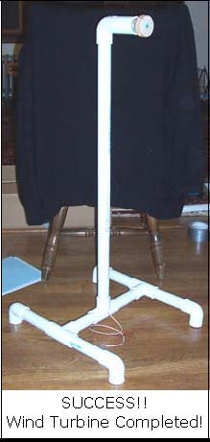
Step 3: Attaching the Tower to the Base

- Snake the motor wires through down the tower and through the hole that is drilled in the PVC tee at the base of the wind turbine.
- Attach the nacelle to the top of the tower.
- Insert the bottom of the PVC tower into the tee at the center of the turbine base.
- It should look just like the wind turbine to the right!
- Make sure the PVC pipe has seated well into the fittings by tapping together with a hammer, or by banging on the floor.
- Make sure that you didn’t use any glue! (Because once you are done you can take it apart and then store it away for next year.)
- To make your life easier you should attach alligator clips to the wires coming out of the turbine. This will make it easy for you to hook your turbine up to a multimeter!


Step 4: Blade Design and Power Output
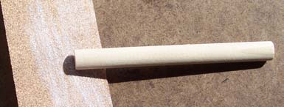
Sand one end of the dowel until it fits snugly in the tinker toy hub. You can also cut a slit, but this can be challenging. You can also use Tinkertoys, but they are rather pricey.
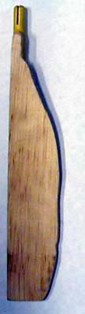
- Attach blades to the hub using the short dowels included if you are using a Basic PVC Turbine Kit from Kidwind.
- The 3/8” dowels are purposely a tiny bit too big to fit into the Tinkertoy holes. To make them fit you must sand some wood away at one end. Don’t sand too much because you do not want the dowels to be loose. If they are too loose, they can fly out during testing.
- To make blades, carve or cut different shapes and sizes out of a variety of material (wood, cardboard, felt, fabric) and hot glue or tape them to the dowel. We have seen students make blades out of styrofoam bowls, pie pans, paper and plastic cups. Basically, anything you can find around your house or classroom!
- Before testing make sure that the blades are securely attached to the dowel or Tinkertoy rod. If you do not secure them properly, they may detach as you begin to test your turbine.

Observations and Other Ideas
- If you do not want to sand dowels we recommend getting a can of Tinkertoys and use the rods to attach your blades. These work great! We would add them in the kit but they are pricey as one small can is around $20.
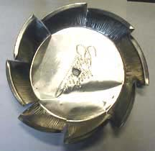
- You can add up to eight (8) blades and set them at any angle on the Tinkertoy hub. The one problem with the Tinkertoy hub is that you can only use even numbers of blades.
- If you want to use odd numbers of blades check out our six (6) hole hubs for sale at the KidWind shop. While these are a little expensive, they allow you to use 3 and 6 blades in an even distribution.
- Be careful that your blades are not too big. They might hit the tower or the ground as they spin around.
- Blades need to be balanced to work properly. If they are not balanced, the entire turbine will vibrate while spinning which can cause problems.

Step 5: Safety & Blade Testing

- It is important to wear safety goggles when constructing blades with hot glue or sharp knifes.
- You should always stand in back of or in front of the wind turbine during testing. If you stand in the PLANE of ROTATION you could be hit if your blade flies off during testing.
- Never make blades using metal or any sharp edged material as these could cause injury while spinning fast during testing.
- The voltage and current made by your turbine is not enough to cause injury. But it is always a good idea to treat electricity with care and caution.

SETUP FOR TESTING:
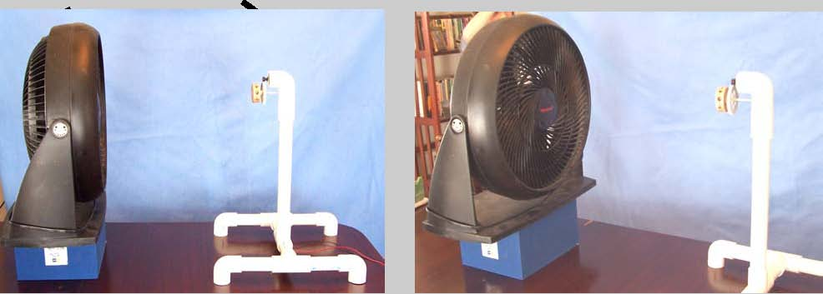
Safely set up your testing area like the picture below. It is important to clear this area of debris and materials.
→ Make sure that the center of the fan matches up with the center of the wind turbine. You may need to raise your fan with some books or a container.
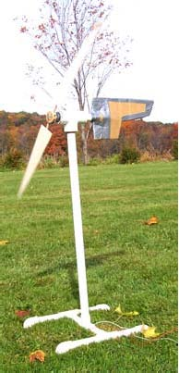
While you can use your wind turbine outside, you must make sure that you face it into the wind. This is because your wind turbine cannot YAW (or rotate) to face the wind. If the wind shifts, and the turbine cannot rotate, it may cause the driveshaft to be blown out of the hole.

Step 6: Measuring Your Wind Turbine’s Power Output

How do we use the multimeter with our wind turbine?
Small DC motors do not produce much power when we spin them slowly. As this turbine does not have any gearing our electrical output will be limited and a great set of blades in high winds might be able to light an LED. To accurately measure our production you should use a multimeter.

Power = Voltage (V) X Current (A) <—-Watch Your Units
Make sure you are recording volts and amps (not milli or microvolts unless you want to!)

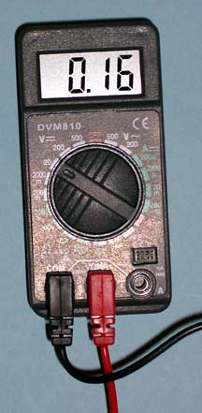
a. Voltage
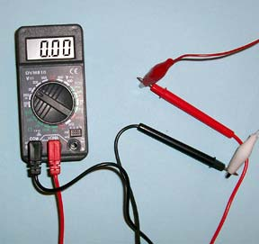
- Attach the wires from the generator to the multimeter.
- To check the voltage select DC Volt (V) and choose a the whole number setting say up to at least 5 volts.
- Place your turbine out in the wind or in front of a fan and let it run up to speed. It is normal for the readings to fluctuate. Power output is not steady because the wind is not steady.
- A set of very well designed blades may make around 1 volt. Typical blades will be in the 0.2 - 0.5 volt range.
- When you are measuring voltage you are measuring how fast the DC generator is spinning. The faster it spins the higher the voltage. As there is no load on the generator it has very little resistance so it can spin very fast. If you look closely when you add a load the RPM may drop as will your voltage.

b. Amperage
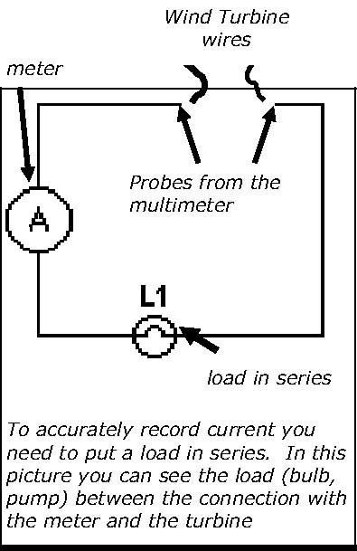
- To get a more accurate picture of the power output of your turbine you should measure amperage as well. To accurately measure the amperage you need to hook up your multimeter differently.
- You need to place a load (or a resistive object - small bulb, resistor, pump etc.) in series with the meter so that the generator is “loaded” and has to do work.
- A set of very well designed blades will make around 0.1 amps (100 milliamps) with this motor. Typical blades will be in the .02-.05 amp (20 –30 milliamp) range. This will vary based on your resistive load.
- When you are measuring amperage you are measuring how many electrons your turbine can push. This relates to how much torque your blades are generating.
  - Before you move ahead to the next step, stop and write down your thoughts about how the energy of the wind is being transformed to electricity. Record the energy transformations in the boxes below.

Step 7. What Kinds of Things Can We Test with the Wind Turbine?

Some Factors that Affect Power Output
Now that you have a wind turbine, it is time to explore the factors that affect how much power your turbine produces by designing your own experiment. (You will need to use additional sheets of paper to describe your experimental and results ☺).
Here are a few ideas to get you thinking about your hypothesis and the factors you would like to test:
- Wind Speed
- Generator Type
- Blades

Option 1: If you want to explore the affects of wind speed, look at questions a and b below and design an experiment to test your ideas.
- How do changes in wind speed cause the power output change?

- Why does it change? Make a graph and discuss with your team. (Think about this in relationship to the Power in the Wind equation.)

Option 2: If you want to explore how blade design affects power output, check out the information below and design an experiment to test your ideas.

The blades on modern turbines "capture" the wind and use it to rotate the shaft of a generator. The spinning shaft of the generator spins magnets near wires and generates electricity. How well you design and orient your blades can greatly impact how much power your turbine produces.
Some variables you can test about blades include:
- Blade Length
- Blade Shape
- Blade Number
- Blade Materials
- Blade Pitch
- Blade Weight

    - How do changes in blade design cause the power output change?

    - Why does it change? Make a graph and discuss with your team. (Think about this in relationship to the Power in the Wind equation.)

Kidwind Project. “Building the Basic PVC Wind Turbine.” http://www.kidwind.org/pdfiles/basicinstv2.pdf, accessed 17 July 2005.

